**Deployment document**

Fontys University of Applied Science Software

Project Plan Individual project:

Tutor: Tim Kurvers & Maja pesic

Student: Mohammed Al Harbi

4089553

Contents

Introduction 3

Requirement 3

Links 3

1. WINDOWS operating system: 3

2. Any Other operating system: 3

STEPS: BACKEND 4

STEPS: FRONTEND 7

Set up admin (A one time action) 9

Closing the application 9

Re-launch Henaknowledge 9

# Introduction

In this document, the requirements needed for deployment shall be mentioned along with the steps needed to deploy HenaKnowledge project locally in your machine.

# Requirement

1. NODEJS
2. DOCKER

# Links

# WINDOWS operating system:

NODE JS LINK x64 bits - https://nodejs.org/dist/v14.17.1/node-v14.17.1-x64.msi

NODE JS LINK x32 bits - https://nodejs.org/dist/v14.17.1/node-v14.17.1-x86.msi

Docker link - https://docs.docker.com/docker-for-windows/install/

# Any Other operating system:

NODE JS LINK - https://nodejs.org/en/download/

Docker link - https://docs.docker.com/get-docker/

# STEPS: BACKEND

1. Graphical user interface, text, application, website

   Description automatically generatedAfter installing docker you should have green docker on the bottom left as in the picture below
2. 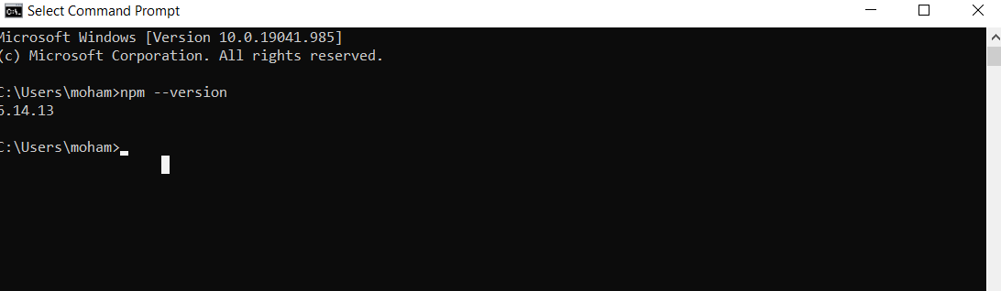After installing node you should be able to type npm –version in your command line (terminal) and get the node package management version displayed as the picture below
3. If you have results as pictures shown it means you have installed everything successfully.

NOTE: do not worry if your npm version a bit older or newer than mine it still should deploy Henaknowledge and make it work.

1. 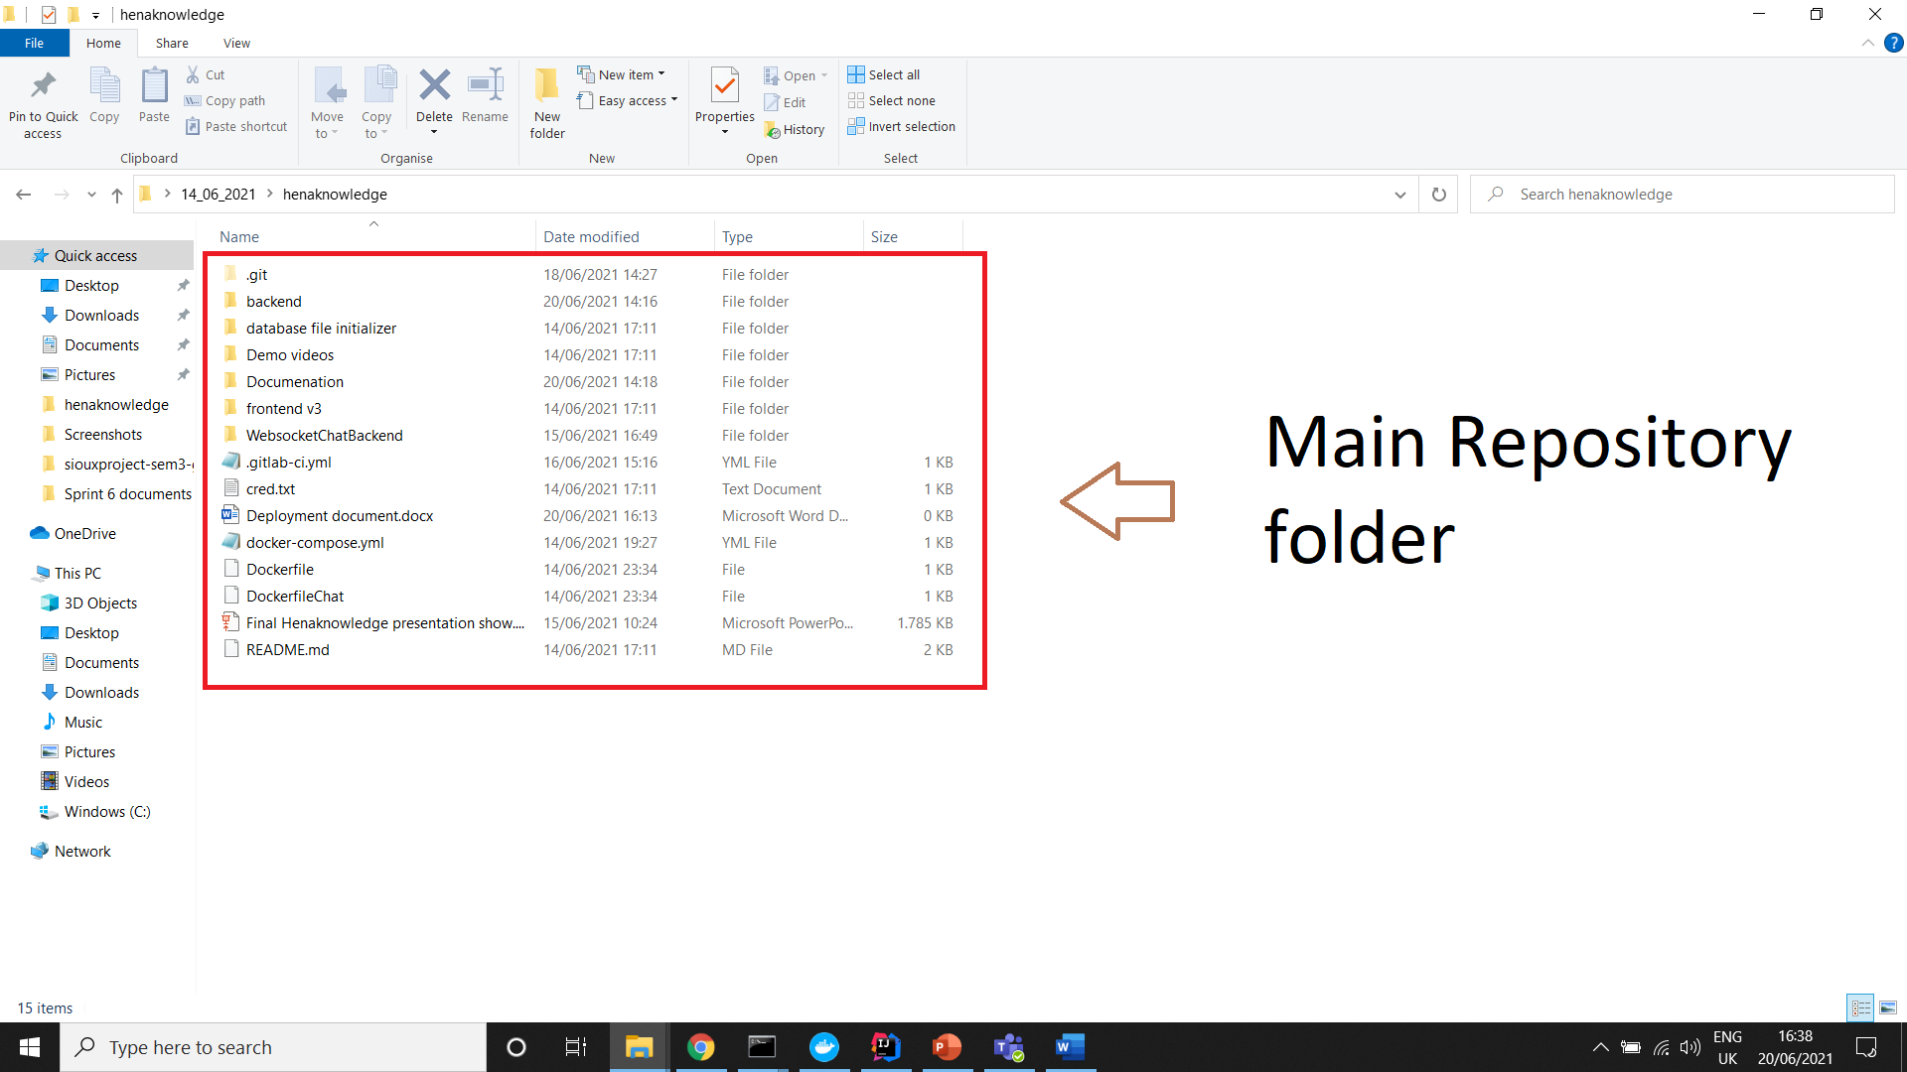Go to main repository folder
2. 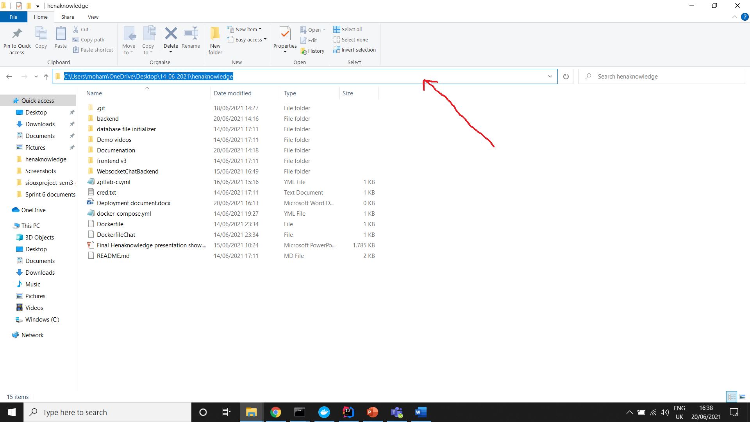Click your mouse on the location path
3. 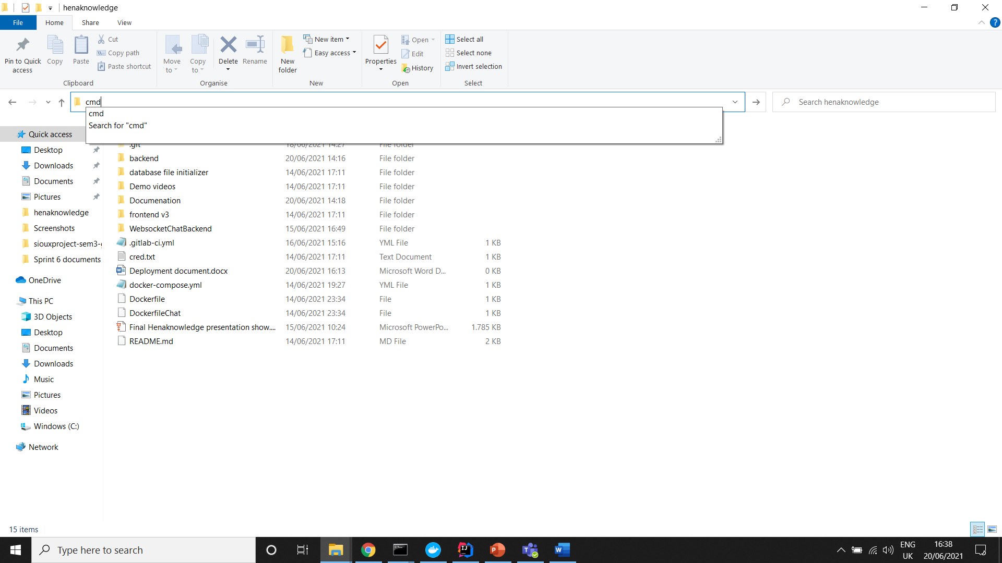Type cmd to open the terminal

1. 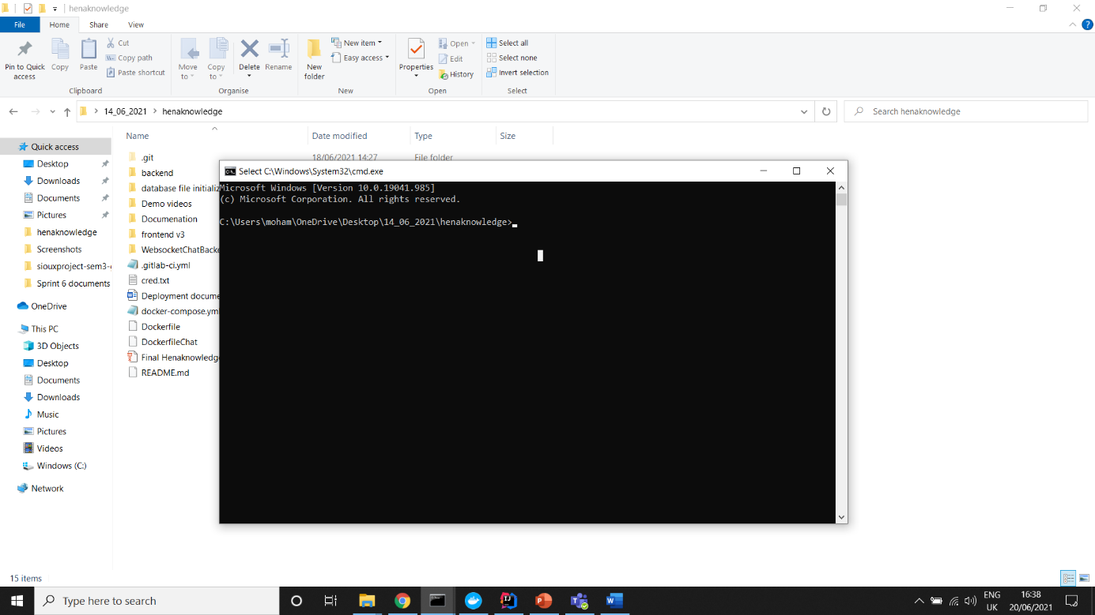You should have the terminal open to where you have Henaknowledge locally saved.
2. Keep docker open in the background and type in the terminal docker-compose up
3. The terminal will download the required files and will build Henaknowledge for you.

* The previous steps will build the backend of henaknowledge successfully. What is left for the moment is to build the frontend.

# STEPS: FRONTEND

1. Graphical user interface, application

   Description automatically generatedOpen the main repository folder
2. Go inside frontend v3 folder and inside henaknowledgefrontend folder
3. 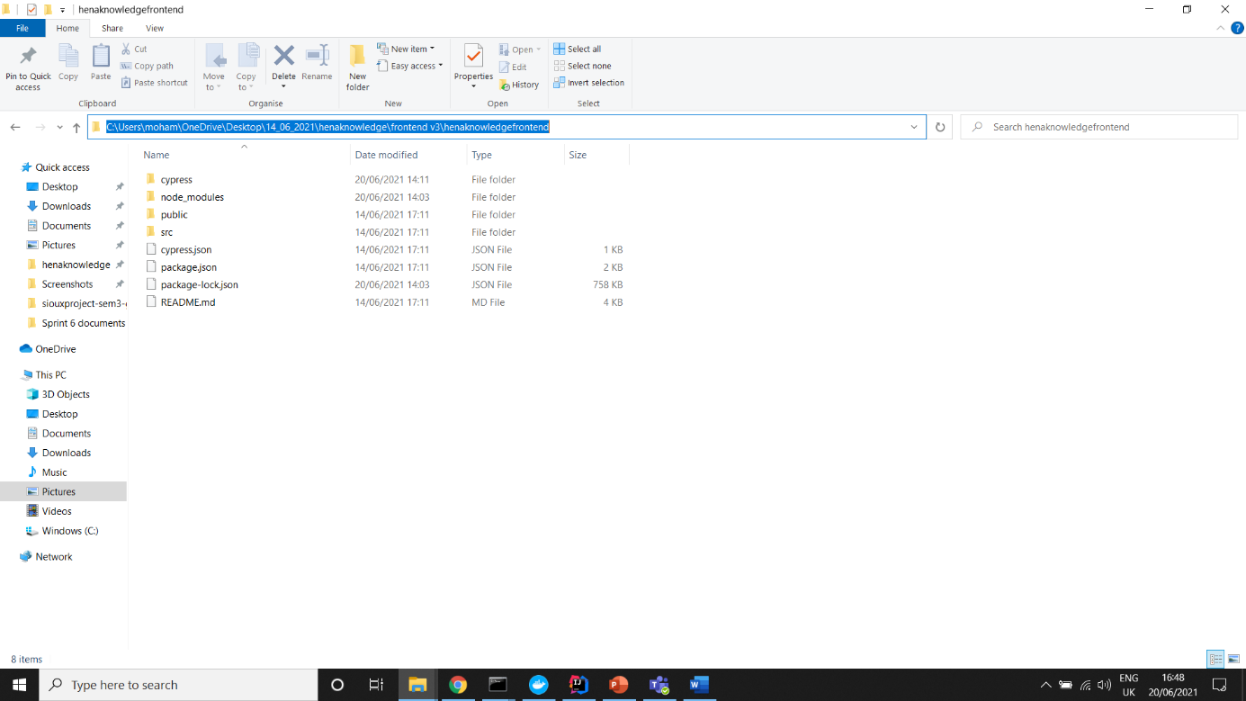You should be in the repository displayed below, click on the location path (just like previously we wanted to open terminal for backend part)
4. 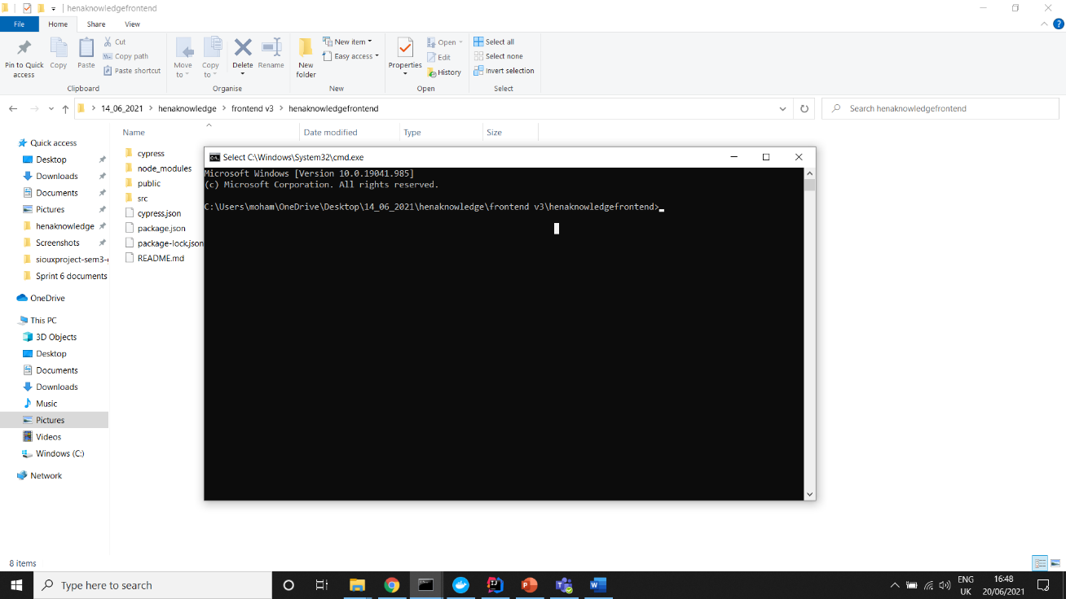Type cmd there and hit enter you should be seeing the terminal open.
5. Inside the terminal type “npm i” (to install all dependencies ) then type “npm start” (to start the frontend).

* By now you should have everything set up and Henaknowledge should work

# Set up admin (A one time action)

<http://localhost:8080/Fake/SetUpAdmin> you should go to this link only ***ONE TIME*** afterfollowing all the steps in this document now you can login with ADMIN as username and password ADMIN to login and then you can use admin privileges to sign up students, teachers and have full access to the project.

# Closing the application

After using henaknowledge you can close it by pressing CTRL + C at the same time in the backend terminal. Then by typing “docker-compose down” this would shutdown the backend and remove henaknowledge running container (but you still have all data of Henaknowledge saved in the image you have in docker, so DO NOT delete the image from docker or you will have to set up admin again and all data will be lost.)

To close the frontend go to the frontend terminal and press CTRL + C at the same time and you should not be able to access any the frontend part anymore.

# Re-launch Henaknowledge

After deploying henaknowledge it is way easier to open it again. Just repeat the steps of opening backend terminal and type docker-compose up

Repeat the frontend opening terminal steps and type “npm start” (no need for “npm i” because you installed everything previously.)